Lesson 1
Introduction to the Sharemarket
What is a share?

Do you know friends or family who own their own business?
The business may be a one-owner business (sole proprietorship) where the owner owns 100% of the business and the profits made by this business. Or the business may be a partnership between two or more people where they may own different percentages of the business. A business owner may decide to incorporate their business into a private company. Some businesses eventually need to seek additional funds to grow their business beyond their network of investors. For example, a retail store may want to open more stores or expand to other countries and need additional investors to fund their growth.
Businesses may choose to become listed on the Australian Securities Exchange (ASX). The ASX is a marketplace, much like a shopping centre with lots of retailers or an online marketplace such as eBay or Amazon. The ASX is a marketplace that brings together companies who need additional funds (equity) with investors who are seeking to buy a share of a company. A business that lists on the ASX becomes a public company.
The ASX has many companies listed that allow for investors to purchase a share of a business, making them shareholders or part owners of a business. Shares in publicly listed companies are sometimes known as equities, stocks or securities. On a typical day, there would be few Australians who do not buy or use the goods and services produced by one or more of the 2,000+ companies listed on ASX.

Activity 1
Outline two features of each of the following business legal structures:
Sole Trader |  | Partnership |  | Private Company |  | Public Company
1. |  | 1. |  | 1. |  | 1.
2. |  | 2. |  | 2. |  | 2.

Activity 2
It is normal for shares to fluctuate in price within a day. If prices have risen since the start of a day, the company will be listed in green on charts. If it has fallen since the start of a day, it will be listed in red.
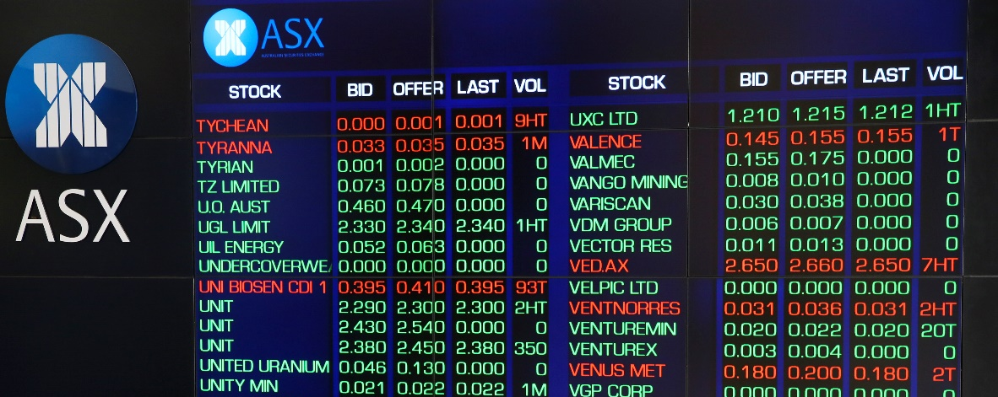
Research by going to www2.asx.com.au Identify the top 5 gains and top 5 declines for the day.
Gains |  | Declines
Top 5 Companies |  | Top 5 Companies
1. |  | 1.
2. |  | 2.
3. |  | 3.
4. |  | 4.
5. |  | 5.

At times, this rise or fall in share price could be the result of major changes or announcements within the company and could signal a long-term decline or rise in share price.
Select one of the companies identified above and investigate reasons why this company has gained or declined recently.

Activity 3

Industry Sectors within the ASX
More than 2000 companies are listed on the ASX. All may be categorised by industry sector using the Global Industry Classification Standard sectors (GICS). Diversifying your investments in a portfolio, across a wide range of companies and industries is thought to reduce your risk.
The following is a list of industry sectors, their relevant code and a summary of what they do.
Classify the following companies into the relevant industry in the table below:
- Woolworths Group Limited (WOW)
- BHP Group Limited (BHP)
- Dexus (DXS)
- Harvey Norman Holdings (HVN)
- Telstra (TLS)
- CSL Ltd (CSL)
- Commonwealth Bank (CBA)
- Carsales.com Limited (CAR)
- Caltex Australia (CTX)
- QUBE Holdings Limited (QUB)
- AGL Energy Limited (AGL)

Sector | Sector Code | Activities conducted by companies  in this sector | Example of companies  in this sector
Energy | (XEJ) | Company activities in this sector centre around oil, gas and coal such as drilling equipment, energy exploration and transportation.
Materials | (XMJ) | Company activities in this sector centre around commodities and related industries such as mining, forest products and construction materials.
Industrials | (XNJ) | Company activities in this sector centre around producing and selling building materials, chemicals, fertilisers and agricultural commodities.
Consumer Discretionary | (XDJ) | Company activities in this sector centre around media, gambling and general retail (goods and services that consumers consider non-essential but desirable).
Consumer Staples | (XSJ) | Company activities in this sector centre around production and distribution of essential products such as food and beverages, household goods and hygiene products.
Healthcare | (XHJ) | Company activities in this sector centre around on medical practice, pharmaceuticals, pathology, medical devices companies and biotechnology.
Financials | (XFJ) | Company activities in this sector centre around banking, insurance, asset management and a range of other financial services.
Informational Technology | (XIJ) | Company activities in this sector centre around software development and IT consultancy.
Communication Services | (XTJ) | Company activities in this sector centre around telecommunication carriers, distributors and resellers.
Utilities | (XUJ) | Company activities in this sector centre around electricity and gas retailing.
Real Estate | (XPJ) | Company activities in this sector centre around residential, commercial and industrial real estate management, construction, and sales.

Terminology (skill directives)
Identify – Recognise and name; establish or indicate who or what someone or something is.
Outline – Sketch in general terms; indicate the main features of; Plan, collect and interpret data/information and draw conclusions about
Investigate – Plan, inquire into and draw conclusions about
Classify – Arrange or include in classes/categories

Glossary
Diversification – A strategy that mixes a wide variety of investment types and sectors within a portfolio for the purpose of minimising risk.
Equity – The amount of money invested into a business by shareholders.
Fluctuate – When shares rise and fall irregularly in price.
Industries or sectors – A group of companies that are related based on their main business activities.
Investor – a person or business that puts money into the purchase of company shares with the expectation of financial return.
Marketplace – Is a physical or internet-based location where buyers and sellers regularly gather for the purchase
and sale of goods.
Partnership – A business structure made up of two or more individuals or corporations who work together to run a business.
Portfolio – A range of investments within the sharemarket held by a person.
Private company – A legal structure that is separate from the owner, where only a limited amount of people may invest as it is privately owned.
Shareholder – An owner of shares in a company.
Sole proprietorship – A business that is owned and controlled by one individual.

