Lesson 10
Celebrating Indigenous Involvement in the ASX

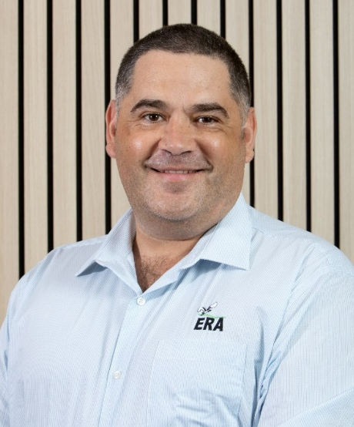
Meet Australia’s first Indigenous Managing Director and
Chief Executive of an ASX500 company – Brad Welsh

By Roset Khair, December 2022
When most people think of Indigenous cultural representation and activism, the usual ideas that come to mind include things such as NAIDOC week, reconciliation days and protests. However, Australia’s first Indigenous ASX500 CEO Brad Welsh highlights just how important change from within the corporate sector can also provide fulfilment and impact for the Indigenous community and wider Australia.
Growing up in Redfern, Sydney, Welsh worked in his youth to pay for necessities such as the electricity bill. He was not the ideal student, with teachers often saying he had potential but needed to apply himself better. However, he has not allowed his humble beginnings to limit the impact he has since had in the world of business, becoming a leader and pioneer within the industry of mining and in the field of environmental sustainability.
Brad Welsh, CEO of ERA Ltd
Currently Welsh is the Chief Executive Officer (CEO) and Managing Director (MD) of Energy Resources of Australia Ltd (ERA), a company floated on the ASX in July of 1980, in what was at the time the largest ever public float in Australian history. In 2000, a majority stake was acquired by Rio Tinto, one of the biggest companies listed on the ASX. Currently Rio Tinto remains the majority shareholder of ERA. The company has evolved over the years, with a changing focus on Environmental, Social, and Governance through its revitalised purpose, values, and priorities.
ERA's purpose is to create a positive legacy and achieve world-class, sustainable rehabilitation of former mine assets.
(Energy Resources Australia, 2022)
It is Welsh’s unique life experiences that have allowed him to be the impactful leader needed for such an important role, leading ERA Ltd as CEO. He began his career in social work after completing a Bachelor’s degree in Welfare (Aboriginal Community Studies). While working in this field, he completed a Law degree, hoping to make an even greater impact on the Indigenous community he worked with.
It led to him eventually transitioning to the role of Media Assistant to Kevin Rudd a few months prior to the GFC in 2008, before moving to the role of Senior Advisor to Kristina Kenneally, NSW Planning Minister at the time. It is than that he realised that he could make an even greater impact, giving voice to remote Indigenous communities impacted by mining.
He continued his studies, completing a Masters in Mining Engineering which eventually led to him holding advisory and managerial positions within Rio Tinto before being appointed to the role of Chief Executive Officer of ERA Ltd in February 2022, a part of the Rio Tinto group of companies. He describes his career as being a mixture of “preparedness meets opportunity.” Welsh recognised the importance of mining as a long-term investment for Indigenous communities not tapped into at this point.
“Having Indigenous leadership in the centre [of business] and driving investment is beneficial as many of these communities do not have alternative investments – I wanted to be part of the solution and not part of the problem”
He emphasises that in his role as CEO that, beyond the day-to-day complexity of working through an array of shareholder concerns and catering to their changing interests, working with such diverse interests to guide the company’s strategy provides a sense of custodianship. He remarks this is a striking parallel to the Indigenous sense of custodianship of the land and one’s people in which the leader takes something and ensures they leave it in a better place than how it was first received.
“The presence of your leadership is far more impactful than practice of your leadership and by being in such a position in the corporate sector you get the chance to be of a minority and harness the future of the company using Indigenous thought at the centre.”
“Having Indigenous leadership in the centre [of business] and driving investment is beneficial as many of these communities do not have alternative investments – I wanted to be part of the solution and not part of the problem”
He emphasises that in his role as CEO that, beyond the day-to-day complexity of working through an array of shareholder concerns and catering to their changing interests, working with such diverse interests to guide the company’s strategy provides a sense of custodianship. He remarks this is a striking parallel to the Indigenous sense of custodianship of the land and one’s people in which the leader takes something and ensures they leave it in a better place than how it was first received.
“The presence of your leadership is far more impactful than practice of your leadership and by being in such a position in the corporate sector you get the chance to be of a minority and harness the future of the company using Indigenous thought at the centre.”
Activity 1

Comprehension Activity
Read the above article and respond to the following comprehension questions:
- What is meant by Welsh’s statement, “preparedness meets opportunity”?

- Define the concept of custodianship of the land.

- In the article, Welsh is said to be from the Indigenous Muruwari tribe. Explain what is meant by this.

- Welsh refers to Indigenous culture as being a ‘high context culture’. Outline what he means by this.

- What does it mean to “separate the signals from the noise.”?
Activity 2

Research Task
Go to https://www.energyres.com.au/ and watch the video titled ‘Get to know the new ERA’ to better understand the purposes, values, and priorities of ERA Ltd.
Create a research report or presentation on Energy Resources of Australia Ltd. In your report/ presentation you should address the following criteria:
- Identify the stakeholders of the business.
- Outline the history of ERA Ltd.
- Analyse a project that ERA is currently working on. How will this project benefit the environment and the local Indigenous people?
- Using examples from your research, discuss the importance of Environment, Social, Governance (ESG) in relation to ERA Ltd. (You should address every component of ESG).

Terminology (skill directives)
Analyse – Identify components and the relationship between them; draw out and relate implications
Define – State meaning and identify essential qualities
Discuss – Identify issues and provide points for and/or against
Explain – Relate cause and effect; make the relationships between things evident; provide why and/or how
Identify – Recognise and name; Establish or indicate who or what someone or something is.
Outline – Sketch in general terms; indicate the main features of; plan, collect and interpret data/information and draw conclusions about

Glossary
Cash Flow – The money coming into and leaving a business.
Chief Executive Officer (CEO) – The highest position in an organisation and is responsible for ensuring the fulfilment of the vision, mission, and values of an organisation through strategic planning, leadership management.
Competitive Advantage – Having a distinct advantage over other businesses based on measures such as market share, profitability, sales.
Environmental, Social, and Corporate Governance (ESG) – term used to describe a company’s commitment to ensure that they contribute positively to the world community through their policies and day-to-day operations. This may be achieved by addressing the issues of climate change through their corporate policies and operations, or how they manage relationships with their stakeholders such as employees, suppliers, customers, and the wider community. They go beyond legal requirements, ensure transparency, ethical actions, and social justice.
Float – This is when a company issues shares to the public for the first time. Another term used is Initial Public Offering (IPO).
Managing Director (MD) – Includes the responsibilities of that of the CEO and also a representative of the shareholders on the Board of Directors.
Stakeholder – Someone holding a concern or interest in a business.
Values – Things held in the highest regard in an organisation and are central to all decision making.

