Lesson 2
How the Sharemarket works:
The Primary and Secondary market

Shares are bought and sold on the share market. The share market is like any other market where buyers and sellers come together for the purposes of exchange. In the same way that groceries are sold in a supermarket, arty items are sold on Etsy, and a variety of items are sold on Amazon or eBay, shares are sold by companies on the sharemarket to investors. But shares need to be created before they can be bought or sold – so where do they come from?
The Primary Market

Shares are first issued on the primary market. That is the starting point and from then on shares are traded on the secondary market. The process of listing the shares is known as a float.
The Sharemarket is a place where buyers and sellers come together to trade.
A company is a business that is a participant in the sharemarket with the expectation that they will acquire funds (equity) from investors that they can use to grow their business.
Investors can either be a business or an individual who participates within the sharemarket by purchasing shares, with the expectation of receiving a financial return from their money (also known as a capital commitment).
Companies then use these funds to expand the business by investing in different areas. For example, a retail supermarket may want to enter the sharemarket to raise the $100 million it needs to expand by opening stores in other states. Investors then expect that the profits generated by this expansion will lead to a payment in dividends and an increase in the share price (capital growth).
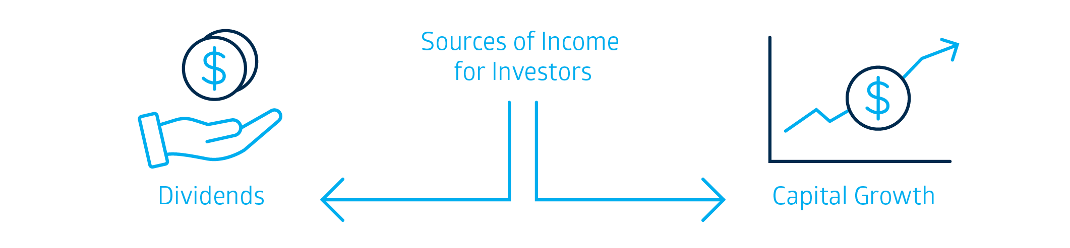
Becoming a Listed Company
Not every company can have its shares traded on the sharemarket. It must have already operated as a private company successfully for a period of time and be large enough to qualify. This is to give investors some confidence that it is a stable company. However, this does not provide a guarantee that the company will provide a good return on investment – all investment has an element of risk, and it is up to the investor to weigh up this risk and decide if they are still willing to invest in the hopes of a return on their investment.
To make it safer for investors, there are rules that must be obeyed by companies who decide to list on the ASX. One of these rules is to immediately tell the public about anything that would influence their decision to buy or sell shares in the company. Some instances include a change in the profits they expect, or buying a new business. For example, a mining company may have found a new deposit of gold, which may indicate that they may have increased profits in the next few years, or a medical company may be facing legal action over a medical issue with one of the medicines it produces, indicating additional costs to the company. Often these types of changes are those that may lead to an increase or decrease in share price. These are known as announcements and are there to assist investors in making an informed decision about their investment. Access latest market announcements using this link: https://www2.asx.com.au/markets/trade-our-cash-market/todays-announcements
Further information on listing requirements may be found using this link: https://www2.asx.com.au/listings/how-to-list/listing-requirements
Buying Shares in a Float
A float is when a company issues shares to the public for the first time. Another term used is Initial Public Offering (IPO). A company issuing shares for the first time must issue a Product Disclosure document (also known as a prospectus) describing its business and financial situation. A Product Disclosure document is an official document that has been lodged with and registered by the Australian Securities and Investments Commission (ASIC). People apply for shares using a form included within the offer document, and often they may use a broker to assist them with this process. If there are many investors interested in the float, investors may receive only some of the shares they applied for (or even none at all). If this is the case, then the investment money will be refunded to those who missed out. Once the shares have been issued the shares begin trading on the secondary market. This is when those shares issued by the company can be sold to other investors. Some shares go up quickly after they are available for trading – especially if a lot of people wanted shares and missed out on the float. Others with less interest may go down in value.
The operation of public companies is highly regulated by the Corporations Act 2001 (Cth), and overseen by the Australian Securities and Investment Commission (ASIC).

Types of Legal Structures
A business in Australia can be classified based on:
- Its size (based on the number of employees it has or the profit it derives from day-to-day operations)
- The industry sector it is in
- Its legal structure
- Its geographic location

Activity 1
The following are the main types of legal structures in Australia and their main features. Identify some examples of these types of businesses.
 | Sole Trader | Partnership | Private Company | Public Company
Examples of types of businesses | Local plumber, hairdresser, cleaner, small take-away | Lawyers, accountants, doctors, vets | Café with 10 branches around Australia | Mining businesses, telecommunications business, national retailers, international airlines
Name some examples of some of these businesses | 1.  2.  3. | 1.  2.  3. | 1.  2.  3. | 1.  2.  3.
Usual number  of owners/ employees | - One owner (shareholder)  - Less than 20 employees | - 2-20 owners (with some exceptions eg. Legal and accountancy can have up to 200 partners). | - 1 – 50 shareholders | - Minimum of 5 shareholders, unlimited amount of shareholders/owners.  - Usually have 200+ employees.
Features | - Owner has unlimited liability.  - All profits are retained by the owner.  - Less paperwork and legal reporting making it a quick, inexpensive and easy way to start a business.  - The owner makes all of the decisions. | - Governed by the various Partnership  Acts in each state across Australia.  - Owners/shareholders have unlimited liability. | - A legal entity separate from its shareholders.  - Must comply with the Corporations Act 2001 (Cth).  - Owners/shareholders have limited liability.  - Overseen by the Australian Securities and Investment Commission. | - A legal entity separate from its shareholders, listed on the ASX or another exchange locally or globally, and must therefore issue a prospectus to potential investors and follow the requirements set by the ASX and ASIC for public companies.  - Must comply with the Corporations Act 2001 (Cth).  - Owners/shareholders have limited liability.  - Overseen by the Australian Securities and Investment Commission.

Activity 2
Outline two of the main differences between a Private Company and a Public Company
1.
2.

What is in a name?
A business that is registered as a private company must have PTY LTD listed after its trading name. A business that is a public company must have LTD after its trading name.
The Secondary Market
Once a share has floated and shares have been purchased by investors initially, shares are sold on the secondary market – in a way much like a second-hand car market.
After a company has listed on ASX and shares have been issued to investors through the primary market, the shares can be sold to other investors in the share market. Listing of companies on the market and the daily trading of their shares is a regular activity of the Australian Securities Exchange.

Market forces
Demand refers to how many people want to buy something and how much they are prepared to pay. Supply refers to how many people are prepared to sell something and the price they want for it. The sharemarket is like any other market - price is decided by the forces of supply and demand.
When there is a lot of demand by investors for a particular company, the share price will rise. If there is falling demand for the share, the price will fall.
The following is an example of shares for ABC Construction Ltd, a fictitious company on the share market. Due to announcements that they are ahead of time in completing a major construction project, the demand for their shares increases as investors anticipate greater dividends, causing the price of their shares to increase. If the opposite was to happen and a major delay was to impact on the finishing date of the construction project, then shareholders may decide to sell their shares, leading to a drop in demand for those shares due to a fall in anticipated dividends.
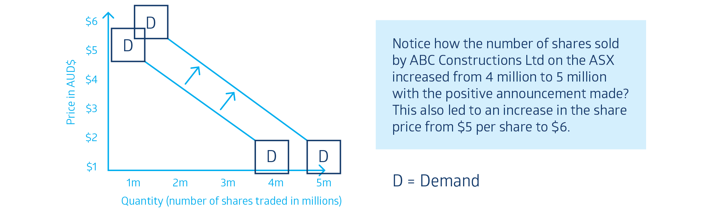

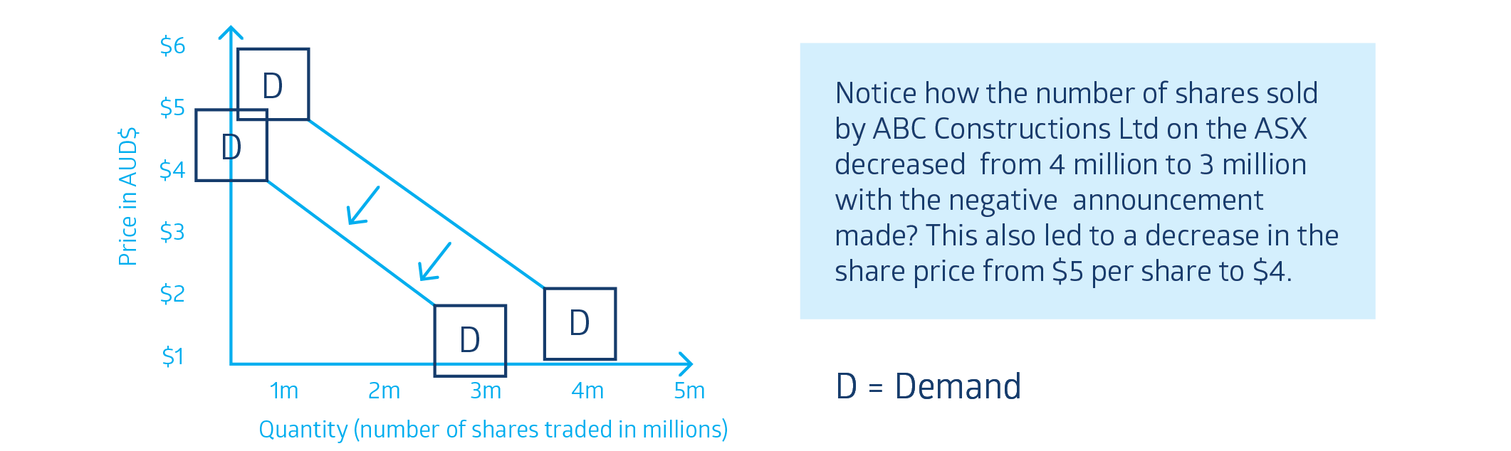
How the Sharemarket works
Buyers and sellers in the sharemarket exchange shares for a particular price. When both buyer and seller agree on a price per share, a trade takes place.
The following table shows how shares are traded on the secondary market:

Table 1: Company XYZ
Buyer | Bid Price | Seller | Ask Price
Buyer A | $1.00 | Seller D | $1.05
Buyer B | 99 cents | Seller E | $1.00 | = Trade
Buyer C | 98 cents | Seller F | $1.06

As seen in Table 1, there are three buyers and three sellers of shares in XYZ Company. Buyer A is prepared to buy XYZ shares at $1.00 per share. Buyer B and C prefer to pay less so Buyer A has placed the highest “bid”. For a trade to take place there needs to be a seller wishing to sell the shares at $1 per share and that is Seller E.
The lowest price a seller is willing to accept for their stock is called the “Ask” price (because that is the price that the seller is “asking” for the stock). Seller E has agreed to sell XYZ shares at the lowest price being $1 per share. Seller D and F are expecting to sell their shares at a higher price so will either have to wait for a buyer to agree to buy the shares at that higher price or they will have to drop their asking price in order to sell the shares.
The price of shares on the secondary share market is determined by demand and supply just like other markets. When the demand for a stock is greater than the number of shares available at a particular price, the price of the stock increases. When there is no demand for a stock at a particular price, the price falls.

Activity 3

Revision for Lesson 2
- Explain how market announcements may impact on share prices.
- Distinguish between the primary and secondary markets.
- Outline the benefits and risks of a company changing its legal structure from being a private company to a public company.
- Outline the listing requirements of a company changing its legal structure from being a private company to a public company.
- Analyse how supply and demand may impact on share price after using an existing company on the share market as an example.

Terminology (skill directives)
Identify – Recognise and name; establish or indicate who or what someone or something is.
Outline – Sketch in general terms; indicate the main features of; Plan, collect and interpret data/information and draw conclusions about
Explain – Relate cause and effect; make the relationships between things evident; provide why and/or how
Distinguish – Recognise or note/indicate as being distinct or different from; to note differences between
Analyse – Identify components and the relationship between them; draw out and relate implications

Glossary
Dividend – a sum of money paid by a company from its profits to its shareholders.
Capital Growth – an increase in the value of funds invested over time.
ROI – return on investment.
Cth – Corporations Act 2001
ASIC – Australian Securities and Investment Commission
Prospectus – document that describes the activities (including financials) of a business to prospective investors.
Regulated – to control the activities of businesses by means of rules and regulations.
Investors – a person or business that puts money into the purchase of company shares with the expectation of financial return.
Float – the initial time a company issues shares in the Sharemarket.
Unlimited Liability – when the owner of a business holds all legal responsibility for the financial performance of the business, particularly when the business has financial difficulties.
Broker – an organization or person used by a shareholder to manage the process of buying and selling of shares.

