Lesson 3
Why do share prices change?

Factors influencing the share price of companies
There are many factors impacting on why the price of shares go up or down in the market. While it may be easy to attribute this to the market mechanism of supply and demand, there are reasons behind why there may be more buyers or sellers in a market. While some of these reasons may be directly related to the specific actions of companies, others are general, broad market factors. The influences can be categorised as internal or external influences.

Internal Influences on share price
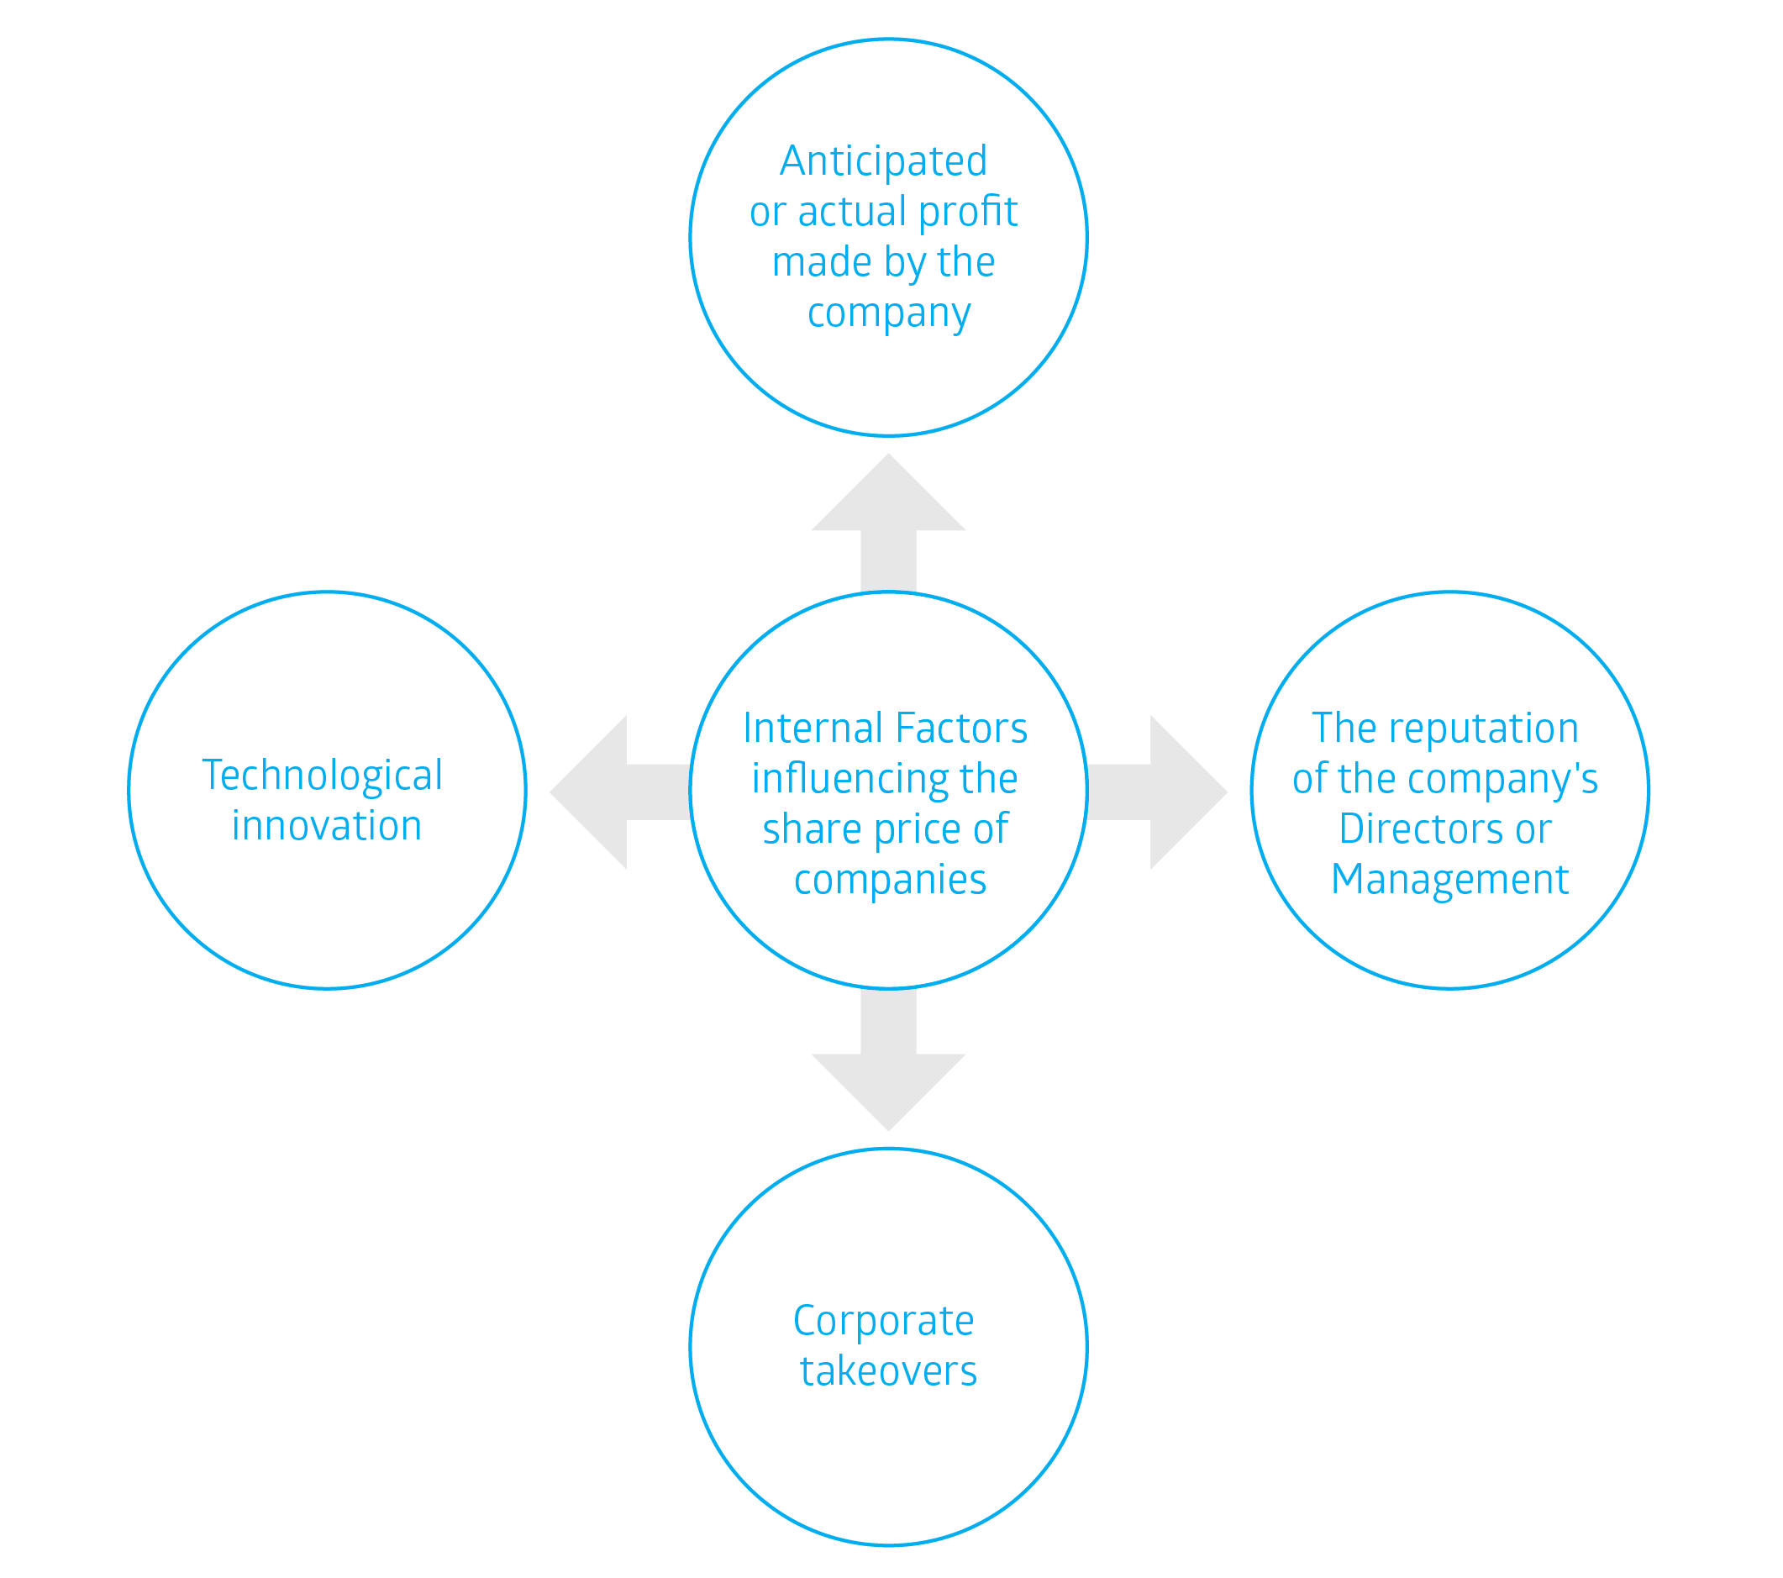
Internal influences are the factors that a company has direct control over that may impact on the business and its success. The following are some of the internal factors that may impact on share price:

Anticipated or actual profit made by the company
Companies regularly issue reports to the market on their activities. These reports include financial statements which report on whether they are earning income, whether costs are up or down and importantly, whether the company is making profits. Another important element of company reporting is providing comments on how they expect the company to perform in the future. Companies that make favorable future profit projections or surprise the market with higher-than-expected profits often experience a rise in their share price. The opposite can trigger a fall in share price. At times, even a rise in profits will lead to investors selling their shares as they may have expected even greater profits than were delivered.
The reputation of the company’s Directors or Management
The market’s opinion of management within a company will have some effect on the price of its shares. For example, the news that a new managing director has been appointed to a company may influence a share price positively if that person is considered to be the right person for the job. Similarly, a favourably viewed Chief Executive Officer leaving a company may lead to some investors selling their shares.
Corporate Actions such as Corporate Takeovers
An individual company’s share price may also change if another company tries to take it over by making an offer to buy a large amount of its shares. Generally, companies launch takeover bids because they expect they will make more money by combining with the other company. It is unusual for takeovers to succeed unless the company making the takeover bid offers more than the current market price for the other company’s shares, resulting in the target company’s shares going up during a takeover bid. There are legal restrictions relating to corporate takeovers as this may result in reduced competition in some markets. For example, having two major supermarkets in Australia merge due to a corporate takeover, may lead to less competition in the market, leading to higher prices due to the potential monopoly formed.
Technological innovation
New and innovative products or processes may positively impact on a company’s share price as this may signify potentially strong profit growth in the future. For example, a company producing medical items may have a breakthrough with a new vaccine or cure for an illness, which could attract new investors in the hopes of the potential profits earned by the company, and the eventual dividends to be paid.

Activity 1
Predict whether the share price is likely to rise or fall in the following scenarios:
Scenario | Rise | Fall
- Fancy Fashions Ltd has signed a contract to supply dresses and jackets to a chain of retail
stores in London.
- A shock announcement to the press that the Managing Director of XYZ Ltd has fraudulently taken funds from the company for several years.
- Sigma Medical Ltd has found a cure for baldness.
- Eureka Ltd, a mining company has just released a drilling report stating that more oil than first anticipated had been found and is now being drilled.
- Success Ltd has just released its annual report showing record profit for the last financial
year and projected profit in the next financial year is to be even better.

External Influences on share price
External influences are the factors that a company has no direct control over, and can only manage the impact it may have on the company. Successful management will usually lead to an increase in share price with investors choosing to invest their funds in such companies as they perceive that there is potential to increase the value of their investment through capital growth and dividends.
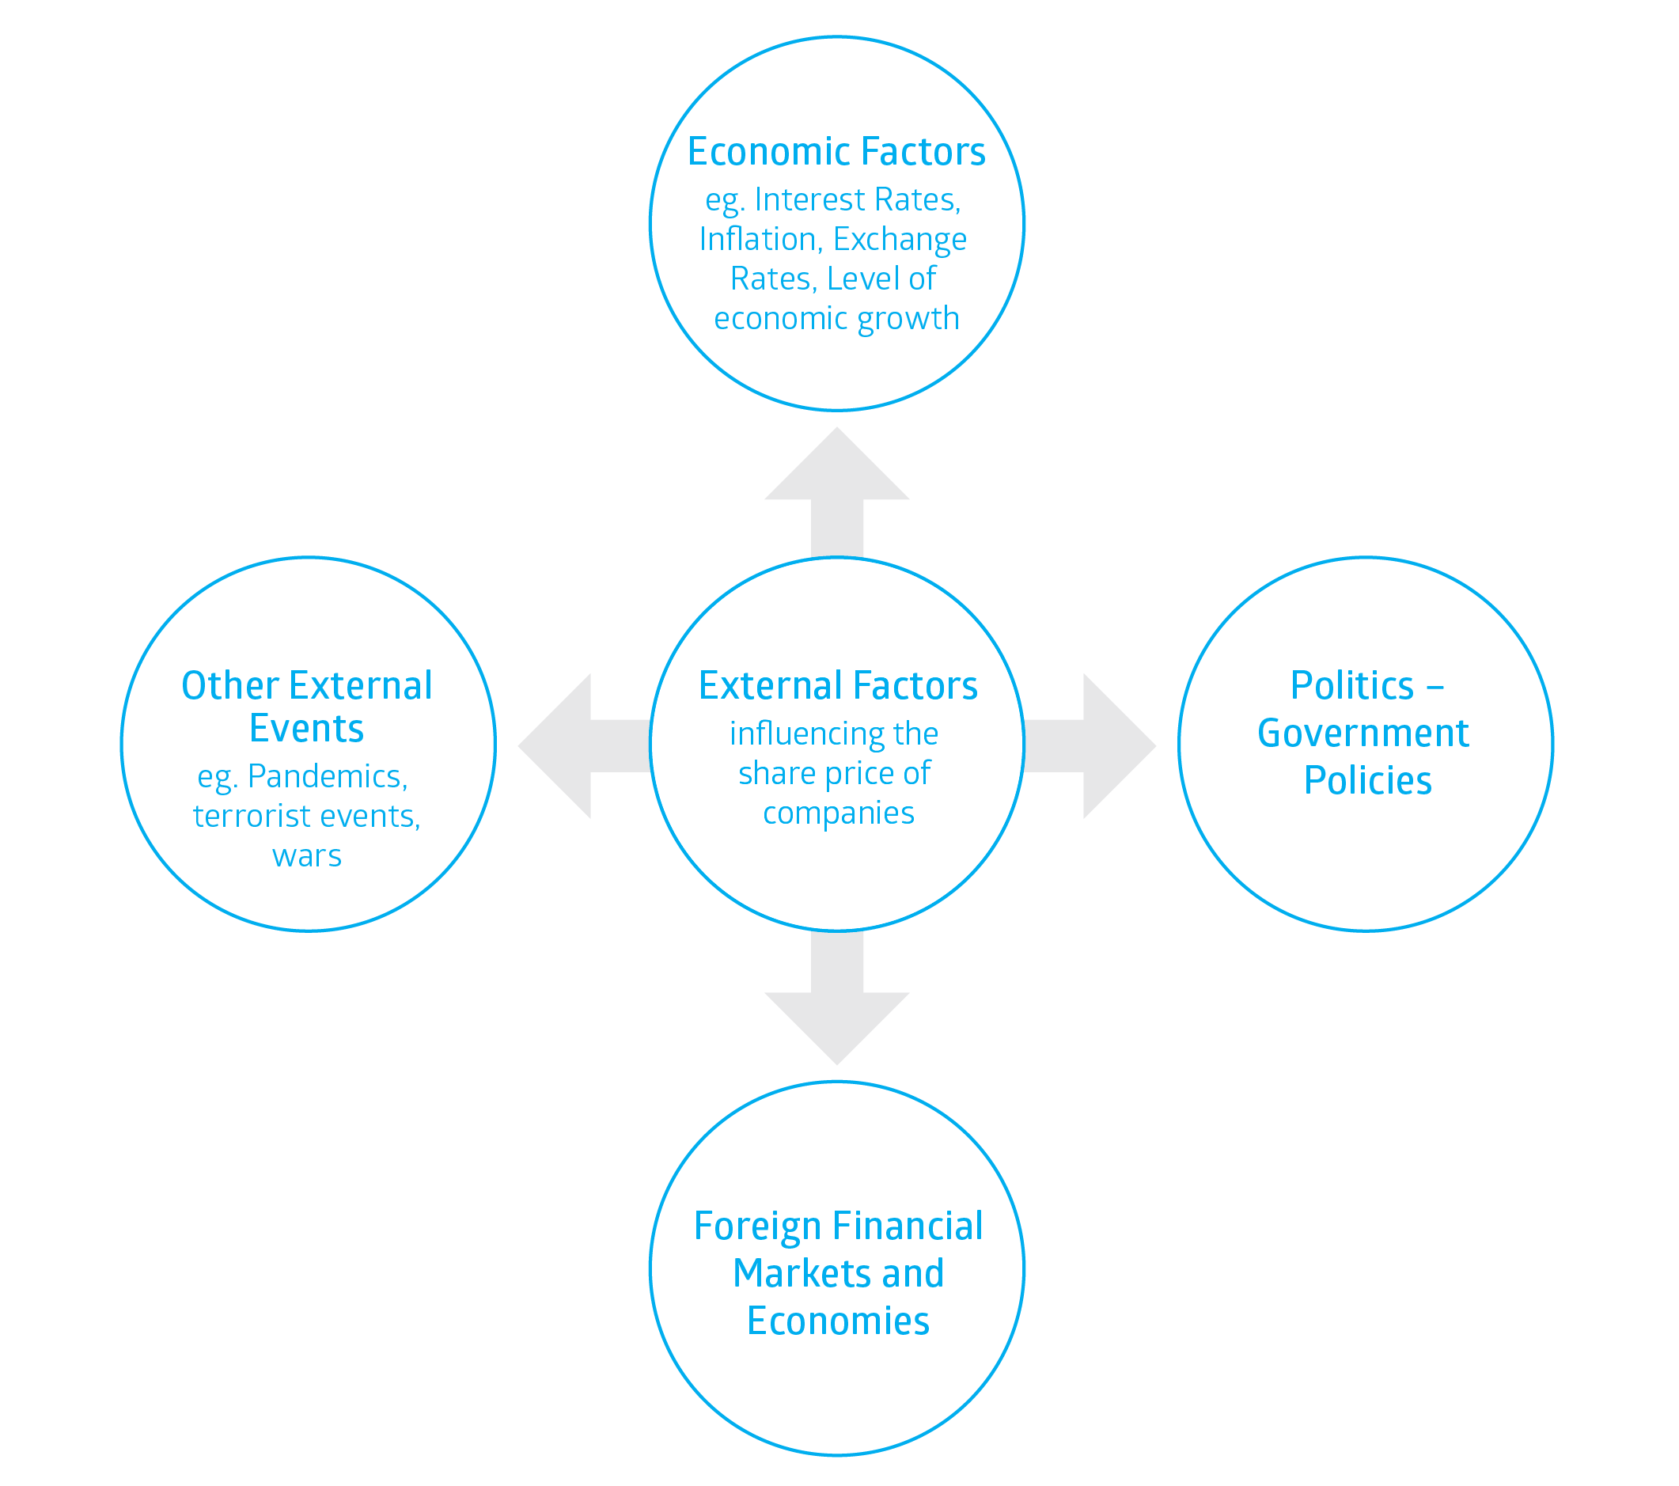
Economic Factors

Interest Rates
Interest is the money charged when you borrow money. High interest rates can directly affect companies because they often borrow money to run their business. Increased interest rates have the effect of increasing their costs. Some companies have a lot of debt and others have no debt so changes in interest rates will affect them differently. For companies that have borrowed a lot of money, increased interest rates could reduce the company’s profits. High interest rates may also affect companies indirectly as other businesses review their future plans. A company with a lot of debt may need to spend less money, which might have an effect on other companies that supply them with materials. Alternatively, the company might cut back on other expenditure such as marketing.
Interest rates also affect consumers. Many people borrow money to buy a house using a loan called known as a mortgage. If people have to spend more money paying off their mortgage, they have less money to spend on other things. Similarly, many people use credit cards to buy things. If interest rates rise, the charges associated with credit cards will go up. People often have to reduce their spending if interest rates rise – particularly on discretionary items (things people don’t regard as essential). Therefore, interest rates can affect consumer spending patterns – this is often referred to as consumer confidence.

Inflation
Inflation is an increase in the prices of goods and services in an economy. This usually happens when an economy grows rapidly, leading to an increase in the cost of producing these goods and services. This affects consumer spending as money has less purchasing power. This may lead to people being unable to buy all of their needs and wants as items become more expensive. This could result in companies making less in profits. Another way that inflation may affect businesses is that inputs in production may become more expensive, meaning there is less profit made by the business. An example of this is a chair manufacturing business that uses polymer (the liquid used to make plastic), may have paid $1m to suppliers in 2021, but then has to pay that same supplier $1.5m the following year despite the quantity and the quality being exactly the same. This leads to higher costs to the business which they may pass on to consumers, possible leading to a reduction in sales which then affects their profitability.

Exchange Rates
An exchange rate is the rate at which one currency may be converted into another. For example, if you purchase from a business in the United States, you must make those purchases in U.S. dollars. The exchange rate determines how many Australian dollars you must pay to buy U.S. dollars.
Exchange rates are determined by supply and demand. Companies importing goods from overseas, either to sell or to use as parts for their products they produce, will benefit from a rising Australian dollar. They can sell their goods more cheaply or enjoy higher profits if they sell their items at the same price. The opposite situation is when the Australian dollar falls relative to other currencies. In this case, the Australian dollar is worth less so Australians have to spend more Australian dollars to buy a foreign currency to purchase goods from overseas.
There are however benefits to a low Australian dollar. It may make it easier for Australian exporters to sell their goods overseas, making it cheaper for overseas consumers to buy Australian made goods.
The exchange rate, whether high or low has the potential to affect the cost of producing goods and services or selling these items in international markets. In both these situations, the skill of management is critical to managing the risks and opportunities.

Activity 2
Caro Ltd is a hypothetical Australian listed company whose main business is producing school chairs, with most of its exports going to the United States. Currently the selling price of a chair is ten Australian dollars (AUD $10). If one Australian dollar is worth USD $0.75 cents a chair would export for USD $7.50.
If the Australian dollar was to rise, with one Australian dollar now worth USD $0.80 cents then with the revised exchange rate, a single school chair would now cost USD $8.00. The US importer would then have to pay 50 cents more for the same chair, which may affect Caro’s sales, leading to reduced demand and therefore profitability for Caro Ltd. Reduced company profitability could lead to a decline in the company’s share price.
- Research the current exchange rate. Calculate how much a chair would cost to the U.S. importer based on the current rate. Use the above as an example of how you would complete the calculation:
- Calculate the price of one chair if the Australian Dollar were to rise to USD $1.05.
- Calculate the price of one chair if the Australian Dollar were to fall to USD $0.50.
- Using your calculations, identify which of the above scenarios would lead to greater sales, and therefore profitability for Caro Ltd?

Level of Economic Growth
Economic growth is an increase in the amount of goods and services produced by a country over a period of time. Economic growth is characterised by increased spending by consumers leading to the need for businesses to produce more goods. For a company on the stock exchange, this means potential to make more profit as consumer purchases increase as they have higher discretionary spending due to greater employment rates in an economy. This discretionary spending may be also used to invest in the share market. This may increase the number of potential investors who seek to take advantage by investing in companies in the hopes of receiving the financial benefits of investing.

Politics

Government Policies
Government policy can have a significant impact on a company’s share price and performance. For example, changes to how companies are taxed may have a direct impact on the profitability of the company and therefore share prices. The tax that investors must pay may have a direct impact on the investments they choose in future.
Government spending can also affect the share market in general. For example, if a government announces increased government funding for infrastructure project such roads or ports, hospitals investors may rush to invest in these areas with the hope that companies able to complete these projects may benefit. Governments may also place restrictions on the operations of some companies. For example, they may decide to bring in new legislation that impact on gambling, medical or technological developments, or weaponry. In the COVID ‘lockdowns’ of 2020 and 2021 we saw government restrictions around the operation of some businesses to limit the movement of people during the pandemic. This had a negative impact on some businesses, leading to a drop in share price, while other businesses such as supermarkets were able to increase their profits as people were not able to dine out freely and instead purchased more grocery items.

Foreign financial markets and economies
The Australian economy and the Australian share market are closely tied to how other countries, particularly some of its biggest trading partners such as China and the United States, are managing their economies. Therefore, a downturn in other economies may affect the willingness of other companies overseas to buy our products, affecting profitability and therefore share prices in the longer run. Movements in overseas share markets can influence the Australian share market. For example, a significant drop in the Dow Jones Index in New York (this is an average share price of the top 30 companies on the U.S. Share Market) may lead to a drop in Australian share prices in Australia when the ASX opens to trade at 10 am (Sydney time). The effect may in part be psychological, as some investors begin to worry that share prices on the Australian share market are likely to fall and sell shares to avoid further losses. Also, large investors that have money invested all around the world might decide to sell shares on the Australian market after big falls overseas. Uncertainty about economic recovery, concern over debt, a slowdown in the economy in any of the major countries, e.g. USA, England, China can all have an impact on the market.

Commodity Prices
The price of certain commodities (e.g. gold, oil, wool, grain, sugar, iron ore, and, copper) on the world market may affect share prices. For example, a company engaged in gold mining is unlikely to achieve exceptional profit results if the price of gold is low. Approximately 30 percent of listed companies on the ASX are in the resource sector, so energy and metal prices can have a dramatic effect on the share market. A booming mining sector may encourage higher prices in other areas of the market and due to investor confidence as a result in higher commodity prices.

Other external events – terrorist attacks, wars, and pandemics
On rare occasions, non-economic yet significant world events may have a destabilising effect on investor confidence. Terrorist attacks, for example may have an effect on people not wanting to travel, affecting airlines and the tourism industry. Wars, such as the Russian invasion of Ukraine, or conflicts in the Middle-East may cause uncertainty in the market, leading to investors selling their shares. In March 2020, as the world faced the uncertainty of how COVID-19 would affect the economy, share prices dropped drastically as investors sold their shares.

Activity 3: Case Study

How has COVID impacted on investors in the Share Market?
The COVID-19 pandemic has had a significant impact on how and what Australian’s invest. However, shares remain Australia’s most popular investment option. Go to https://www2.asx.com.au/investors/investment-tools-and-resources/sharemarket-game/Schools-sharemarket-game-resources/australian-investor-study where you will find information on how COVID-19 has impacted investing in Australia. You may want to watch the video https://youtu.be/gnrsW2uAgEM and download the report ASX Australian Investor Study 2020. Spend a few minutes looking through the document. You may want to look at the contents page and select one the topic areas to look at more closely. Some areas of interest may include:
- The impact of covid-19 on retirement plans
- High value investors
- How many Australians invest?
- Why we invest
- Female investors
- Diversification
- The digital shift
Use the information from this source and your research to develop a 3-minute presentation to share with your class sharing what you have learned about investing in Australia as shown in the ASX Australian Investor Study 2020. Depending on your teachers’ instructions, you may want to do this in pairs or small groups.

Terminology (skill directives)
Identify – Recognise and name; establish or indicate who or what someone or something is.
Predict – Suggest what may happen based on available information.
Calculate – Ascertain/determine from given facts, figures or information.

Glossary
Corporate action - an action taken by a company that impacts its stakeholders and may include a corporate takeover, additional dividend payments, or any other important action that changes the structure of the company, requiring the board of directors to approve it before it being implemented.
Corporate takeovers – when one company tries to take control over another company by making an offer to buy a large amount of its shares.
Capital growth – the appreciation in the value of an asset over a period of time.
Importing – to bring in goods or services into a country from another country as part of the business process.
Exporting – to send out goods or services to another country for the purpose of selling them.
Infrastructure – the basic physical facilities needed by a country such as buildings, roads, power supplies, and ports needed for the operation of a society.
Commodity – a basic good that is produced by a country that is raw material used to manufacture finished goods. This could include basic farming products or mined materials.
Profitability – the money made after all expenses have been paid from operating activities.
Destabilising – to upset the stability of an economy causing unrest.
Consumer confidence – the degree of optimism that consumers have regarding the economy when managing their financial affairs.
Mortgage – a type of loan with an agreement between a borrower and a lender that gives the lender the right to take the property if the owner fails to repay the money borrowed.
Dividend – a sum of money paid by a company from its profits to its shareholders.

