Lesson 4
Getting Ready to Invest

Before you invest you need to save
Savings is the action of putting money away and not spending it. It should be part of a regular plan to put aside money i.e. each year, month, or week into a savings account for future use. Investing is the action of committing those savings to buy something that has the potential to make more money. This could involve buying shares, starting a business, or buying an asset that will likely increase in value over time.
Investing is important because money may lose value over time due to inflation. Inflation is seen through the rise in prices in the economy. For example, a basket of household grocery items (e.g. milk, bread, bananas, etc.) will generally become more expensive every year compared to the previous year. This is because it will cost producers more to produce these items due to the rising cost of the inputs such as wages from using human labour. This means that not only is it important to save, but to also invest.
Most investors start with a small amount of money they have saved over a period of time. These funds are then used to invest by buying things such as shares. Many investors then use any profits made from their investing activities and reinvest them. Saving may involve putting a percentage of your income away and reducing your discretionary spending by creating a budget.
The earlier an investor starts saving and investing, the greater the potential to build long-term wealth. This is because of compounding, a process in which an asset’s earnings are reinvested to generate additional earnings over time. This means that the best returns are usually achieved through reinvesting earnings over a long period of time. For example, if $500 is invested today for one year earning 10% per cent per year, that investment will have earned $50. If that $550 is reinvested for another year, and the return continues at a rate of 10 percent, the $50 earned would earn $55 in the second year. The initial $500 would then be worth $605 (as a result of $50 in the first year and $55 in the second year).

Activity 1
Refer to the example above and then calculate the return if the $605 is reinvested for a further year at a rate of 10%

Identify a savings goal. This should be a number figure.

Create a budget to save for your future investment in shares:
Month | Jan | Feb | Mar | Apr | May | Jun | Jul | Aug | Sep | Oct | Nov | Dec
Income
Expenditure
Surplus/(Deficit)

Total Surplus or Deficit for the year:

Identify the discretionary spending that can be reduced throughout the year to enable a greater surplus.

Investment Alternatives
There are many different types of investments available to investors. A few of the more common investments include:

1. Cash investments
This involves simply putting money into a savings account, which is loaning the money to the bank and in return receiving interest. This is known as a Savings accounts, which is a low-risk investment with interest paid at a relatively low rate compared to other investments. There are other products such as Cash Management Trusts and Term Deposits (these rely on locking-in money for periods of time in exchange for interest), which are usually available at a bank or credit union which allow you to invest your cash at slightly higher rates with additional terms and conditions.

2. Collectibles
These are items that are relatively rare in number such as works of art, sporting memorabilia, and antique furniture. Some of these investments can rise by large amounts. For example, the Australian Government bought the painting called ‘Blue Poles’ by the American artist Jackson Pollock in 1973 for $1.3 million. This was regarded as a huge amount of money at the time. Experts say the painting would now be worth more than 25 times the price paid for it.

3. Property
One of the most common types of investment is purchasing land and/or a building in the hope that it eventually increases in value and can be sold at a higher price to make a profit at a later date. Investors can also invest in property through the sharemarket using a listed property trust, which allows you to invest in a company that invests in real estate that it then leases out to tenants.
Investing in property can be a strong investment with some tax advantages, however it can be very expensive to purchase, forcing investors to often borrow large amounts of money which then have interest and repayments related to the investment. It may also take a while to sell if funds are required quickly. In addition to this, not all property rises in value, determined by supply and demand with some suburbs becoming more appealing or less appealing over time as people choose to live and work in an area. For example, real estate in the mining suburb of Karratha was in the millions in 2010 during a mining boom, but most properties in this area are now a quarter of the price with less people wanting to live there. Other areas have remained relatively stable, rising steadily over time such as a house in Sydney Harbour where there is still a lot of demand for homes. All real estate investment has risk; however, some people may still prefer to invest in real estate as it is a tangible “bricks & mortar” investment.

4. Shares
This is one of the simplest and popular types of investments in Australia because of its potential for good returns. As with all investments, an investor needs to assess the potential risks and returns when investing in shares. Shares can be a sound long-term investment, are easy to trade and require only a small amount of money to invest. Like any investment, shares have risks you need to understand before trading.
Getting Ready to Invest

Share investment – Risk and Return
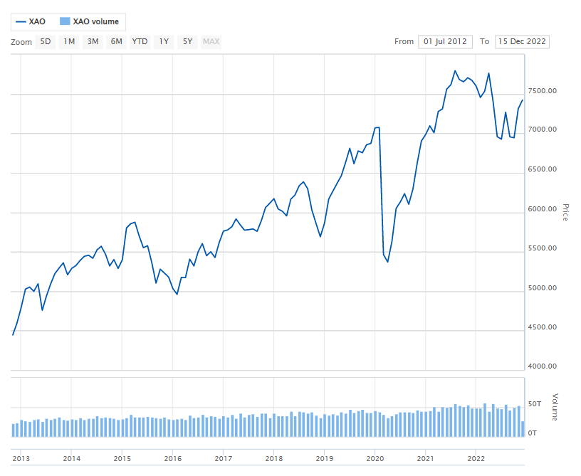
As illustrated by the graph above, the sharemarket can be a profitable investment over the long term. However, all investments have risk. It is up to the individual to decide what level of risk they are comfortable with. There are some ways to mitigate (reduce the level of risk) including researching the companies or industries you intend on investing in and diversifying your investment portfolio (investing across several companies and across several industries), however there are not guaranteed ways to be completely risk free when investing.
While the ASX, ASIC (Australian Security and Investments Commission) and the Australian laws work together to protect participants, many factors may affect the price of shares. Timing may also be a factor in how well a share investment may perform. For example, purchasing shares when shares are at a high and selling them when they fall may lead to a realised loss. Conversely, purchasing when shares prices are low and selling them when they are high will lead to a realised profit. It is therefore important to research, invest in a variety of companies and industries (diversify), have some basic economic understanding, and use company graphs to make predictions about how a company’s shares may perform.

Activity 2
Not only is ASX a nationally recognised market place for buying and selling shares, it is also a registered company on the ASX.
The ASX monthly share price chart and table, December 2021 to December 2022.
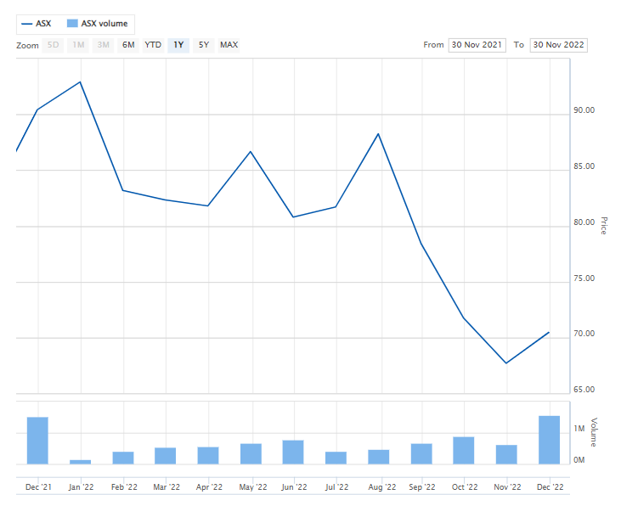

Date | Dec 21 | Jan 22 | Feb 22 | Mar 22 | Apr 22 | May 22 | Jun 22 | Jul 22 | Aug 22 | Sep 22 | Oct 22 | Nov 22 | Dec 22
Closing share price ($)

Using the information in the above table and chart, which tracks the share price history for ASX from December 2021 to December 2022, answer the following questions:
- Calculate the profit/loss in dollars and cents if 1000 ASX shares were purchased on 1 December 2021 and you then sold them on 1 December 2022?

- Calculate the percentage of profit/loss based on the purchase of 1000 ASX shares were purchased on 1 December 2021 and sold on 1 December 2022? (Answer to one decimal point).

- During 2021 ASX paid two dividends. In March it paid $ 1.12 per share and in September paid $1.11 per share.
If 200 ASX shares are held, calculate how much dividend income would have been received in 2021 in total?

Terminology (skill directives)
Calculate – Ascertain/determine from given facts, figures or information.
Identify – Recognise and name; Establish or indicate who or what someone or something is.

Glossary
Investing – Using money to buy something that has the potential to make more money by growing in value or through returns.
Savings – Putting money away and not spending it.
Realised loss – When an asset is sold for a price below the price it was paid for initially.
Tenants – People or organisations that have a right to use a property in exchange for a payment of rent.
Leases – Allowing someone to rent something, usually property and expecting a regular payment as a result for its use.
Budget – Is a personal plan for managing money including possible income, spending and saving.
Risk – The possibility of losing money on an investment.
Credit union – A financial organisation, much like a bank but instead of being owned by shareholders, it is owned by its members who are usually also its customers.
Diversification – A strategy that mixes a wide variety of investments types and sectors within a portfolio for the purpose of minimising risk.
Inflation – The rise in prices of goods and services over time despite the inputs to those goods remaining the same.
Terms and conditions – The rules agreed to before the use of certain products or services.
Return – The amount of money made on an investment relative to how much the initial investment was worth.
Compounding – the process whereby the amount of money that is made on an investment is added to the initial investment, and then reinvested again to potentially grow or make more money.
Reinvesting – Adding money made by an investment back into the investment.
Australian Security and Investments Commission (ASIC) - An independent government organisation that is responsible for overseeing that companies are adhering to the Corporations Act 2001 (Cth).

