Lesson 7
How to buy and sell shares

The ASX is a marketplace where buyers and sellers come together for the purpose of exchange. It is much like a shopping centre with lots of retailers or an online marketplace such as eBay or Amazon.
ASX is a marketplace that brings together companies that need additional funds (equity) with investors who are seeking to buy a share of a company to grow their wealth. There are however a few differences in their operations compared to a traditional marketplace:
- The Australian Sharemarket, although headquartered in Sydney, NSW, does not have a physical location such as a trading floor anymore. Trading occurs via a computerised trading system linking stockbroking firms around the country.
- The operating hours for trades are from 10am to 4pm, Monday to Friday, excluding public holidays.
- An agent, called a stockbroker, buys or sells shares on behalf of a company or individual. There are numerous stockbroking firms authorised to buy and sell shares on the ASX. Some of these firms are called full- service brokers, providing advice and transactions. Other firms are non-advisory, allowing investors to buy and sell shares only after giving instructions to their broker. Further information on stockbrokers and their offerings can be found at https://www2.asx.com.au/investors/start-investing/find-a-broker-adviser .
- Setting up an account with a broker requires completion of paperwork providing instructions and identification details. The broker will require a minimum amount of money to be placed into an account to enable the buying of shares.
- Brokerage is the fee charged by the stockbroking firm for buying and selling shares. This could be a set fee or may be a percentage depending on the level of service provided and the amount invested. This amount can start from as little as $10 per trade.
- When buying or selling shares an order is entered into a computerised trading system at a stockbroking firm. The trading system finds a seller in the market that is prepared to sell shares for the price a buyer is willing to purchase them for.
- A Holder Identification Number (HIN), an identifying number exclusive to each shareholder, is created by the ASX with the purchase of shares. This is shown on the CHESS statement issued to an investor and begins with the letter X followed by 10 digits. CHESS is an acronym for Clearing House Electronic Subregister System, the computer system used by the ASX to track the buying and selling of shares.
- Within two days of a broker executing an order, payment is made. A seller must provide access to the shares they have sold so they can be transferred to the new owner.
- If a purchase of shares is part of a ‘float’ or ‘Initial Public Offering’, this can still be organised through a stockbroking firm. (For more details on buying shares in a float see Lesson 2).
- To buy and sell shares, an investor must be over 18 years of age although arrangements can be made for adults to buy shares on behalf of a minor.

The importance of ongoing research
Even if an investor has a full-service broker, they should seek to have up to date knowledge of the economic, financial, legal, and political influences affecting the market from a local, national, and international perspective. They should also research a company well before investing. It is important for an investor to seek information from diverse and credible sources. This may include referring to the ASX website for updates on a company’s activities, and following publications such the Australian Financial Review www.afr.com, Alan Kohler on ABC News, or a broker’s website such as nabtrade https://nabtrade.com.au/research-and-insights.

Activity 1
Read the following statements and decide whether they are true or false.
Statement | True | False
- An investor must physically go to the counter at the Australian Securities Exchange (ASX) and purchase shares directly from there.
- If an investor wants to receive advice about buying or selling shares on the secondary market,
they should use a full-service stockbroking firm.
- When an investor buys shares, they are buying them directly from the stockbroking firm who
has a supply of them.
- The computerised trading system matches buy and sell orders and then trades them automatically.
- All information should be sought from the same source and at a local level.

Activity 2

Research Task – Career Profile – Stockbroker
Write a one-page report addressing the following criteria:
Identify the qualifications needed to become a stockbroker.
Describe the day-to-day responsibilities of being a stockbroker.
Outline the role of ASIC in relation to stockbrokers.
Identify the training courses needed through the Stockbrokers Association of Australia.
Identify the salary expectations for a stockbroker in Australia.
Outline the requirements needed to ensure a stockbroker’s knowledge remains up to date.

Computerised Trading System
All share trading on the ASX is electronic, with only brokers being able to access the trading system on behalf of investors. The following is an example of what the trading system looks like:
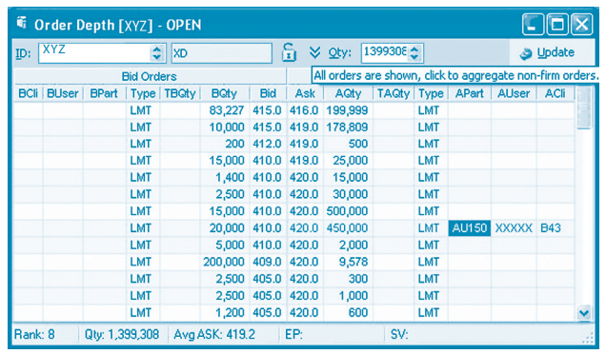

The most common order used on the market is an “at limit” order. This is when investors instruct their broker to buy or sell a security at a given price or better. A request to buy is known as a bid. And a request to sell is known as an ask.
If there is more than one order at the same price, the order that was placed first takes precedence, with larger orders having no priority over small orders. Once investors have instructed their broker to buy or sell shares the order is immediately entered into the trading system by an algorithm.
As demonstrated in the image above, there are 2 orders in the market willing to buy XYZ for $4.15. The quantity of shares to be purchased at this price is 93,227 (83,227 + 10,000). If there is more than one buyer at a price the number of shares each buyer wishes to purchase at this price, it is often added together to show a combined total. The lowest price any seller is willing to sell XYZ shares for is $4.16 and the quantity of shares to be sold at this price is 199,999.
As shown, buyers are wanting to buy XYZ for $4.15 but a seller will only sell at $4.16. Both buyer and seller will need to agree on a price. The buyer(-s) will need to pay one cent more per share or the seller(s) may accept being paid one cent less for XYZ shares. If an investor offers to buy shares at a price higher than the current offer, they may take all the quantity for sale at the best price and then have access to shares on offer at the next best price. Similarly, if sellers offer to sell at a price lower than the current best price, they will move to the top of the queue and have the first opportunity to sell their shares. This is done using the unique HIN given to each investor.

Terminology (skill directives)
Describe – Provide characteristics and features.
Identify – Recognise and name; Establish or indicate who or what someone or something is.
Outline – Sketch in general terms; indicate the main features of; plan, collect and interpret data/information and draw conclusions about.

Glossary
Brokerage – the fee charged by stockbrokers to investors to act on their behalf in the buying of shares.
Equity – The amount of money invested into a business by shareholders.
Float – This is when a company issues shares to the public for the first time. Another term used is Initial Public Offering (IPO).

