Lesson 9
ESG – What is it and why is it important?

Environmental, Social, and Corporate Governance (ESG) is the term used to describe a company’s commitment to ensure that they contribute positively to the world community through their policies and day-to-day operations. This may be achieved by addressing the issues of climate change through their corporate policies and operations, or how they manage relationships with their stakeholders such as employees, suppliers, customers, and the wider community. They go beyond legal requirements, ensure transparency, ethical actions, and social justice. It includes the following broad and inter-related areas.
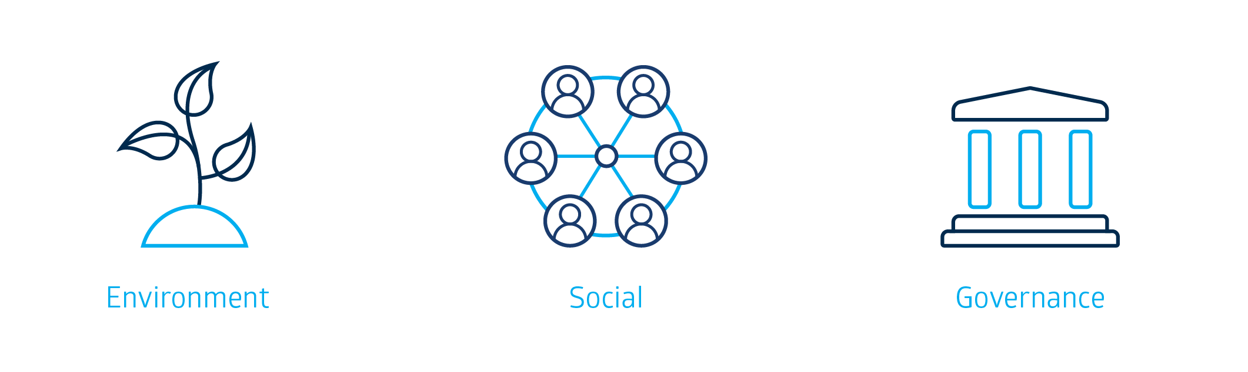
Often referred to as Corporate Social Responsibility (CSR), ESG policies consider the impact a company may have on the physical environment, the people affected by their company including their employees and wider community, and their ethical operations when making financial and legal decisions. Many companies will embed ESG into their strategic goals and vision as they recognize the importance of being a good global citizen, and contributing to the positive reputation of the company among stakeholders such as investors, current and potential employees, communities, and consumers.
ESG demonstrates a company’s commitment to be a better global citizen, and to think beyond making a profit. Their commitment may be demonstrated in the following ways:

Environmental
A company’s response to environmental issues can have a critical impact on how they may be perceived by investors, employees, and consumers and therefore their overall performance. It may impact on whether an investor chooses to buy shares in their company, whether and employee decides to work for a company, or whether a consumer buys their product. It can therefore be a determining factor in whether a company is successful in terms of sales, profitability, expansion, and share price returns (capital growth and dividends). When developing their environmental strategies, a business may have to consider some of the following areas:
- Environmental Pollution – air, land, or sea
- Climate change, including the impact it may have on rising sea levels
- Production and distribution of sustainable natural materials
- Water conservation
- Carbon dioxide reductions
- Being responsible in how they use land – are they protecting natural ecosystems?
What a company focuses on in relation to its environmental policies may be dependent on what the core function of the business is. For example, a construction company that builds homes in the suburbs may choose to only source wood that is renewable and sustainable. An airline may consider the efficiency of its planes to reduce its CO2 production, while a fast-food restaurant chain may consider the content of its waste by choosing to only use recyclable materials, and they may only use renewable sources of energy such as solar electricity to power its restaurants.
A company may also consider the opportunities that a proactive approach may have on its success. For example, a company that produces electricity may consider alternate clean energy sources such as wind, sun, and water to generate the energy needs of its customers. Or a manufacturer of cars may create cars that produce far less CO2 emissions, appealing to consumers who are more conscious of their environmental impact. There are businesses that have shaped their identity around environmental opportunities.

Social
Social responsibility within ESG refers to the fair and ethical actions of a business in relation to its main stakeholders and the community. A company that has a strong social responsibility will consider themselves to be an active participant in the community, developing policies that work to the betterment of society, whilst still allowing them to also achieve profits, and growth. This may include ensuring:
- diversity in workforce
- ethical leadership and workplace practices
- safety of their product on users and the community
- human rights
- poverty reduction
- community impact
- the rights of Indigenous people
Social issues considered depend on the social context and core function of the business. For example, as part of social responsibility, a mining company may be careful about where it places mine sites to protect Indigenous heritage sites, or a manufacturer of clothing who outsources to developing countries may consider the working conditions and the fair remuneration of those producing their goods. It may also mean sponsoring community events such as those related to health or sporting. Other organisations may consider the diversity of those in their workforce such as women and those of diverse minorities and take measures to ensure they are represented at various levels in the organisation, including on the Board of Directors.

Governance
Corporate governance in an organisation is critical to the long-term future and reputation of an organisation. It works to create a culture that is transparent, ethical and fair for all stakeholders. They do this by creating policies that place these values as central to all its operations. These may include policies around:
- anti-corruption
- capped executive compensation
- clear financial reporting in financial statements
- the trust created through the ethical actions of senior management in an organisation
The governance policies implemented by an organisation will depend on the country of operations and the influence of its stakeholders. For example, it will ensure that its financial reporting as part of its financial statements is clear and detailed, going beyond legal requirements, communicating clearly sources of income and expenditure. It may also mean policies limiting the amount of bonuses and salaries paid to executives. It may also mean transparency around payments made to external organisations when setting up projects overseas to limit the taking and giving of bribes.
Activity 1
Use the above table to respond to the following questions:
Recall a time that you, as a consumer, thought favourably or unfavourably of a company because of its ESG policies. What were your actions as a result of this opinion? Your teacher may ask you to share these with the class.

Activity 2
Go to https://www2.asx.com.au/about/corporate-governance
Examine the polices that ASX has embedded in its organisation. Select three of them and outline some of their features.
1.
2.
3.

Activity 3
Most organisations’ ESG policies are based on the United Nations (UN) 17 Development Goals https://www.un.org/en/sustainable-development-goals. Go to https://www2.asx.com.au/about/sustainability/community and explore the ESG initiatives that ASX has supported. Classify which of the UN 17 Development Goals the ASX initiatives relate to.
Activity 4
Justify the importance of ESG policies to a company. You should refer to at least one company as an example.

Terminology (skill directives)
Classify – Arrange or include in classes/categories.
Examine – Inquire into
Justify – Support an argument or conclusion.
Outline – Sketch in general terms; indicate the main features of; plan, collect and interpret data/information and draw conclusions about.
Recall – Present remembered ideas, facts or experiences.

Glossary
Capital Growth – an increase in the value of funds invested over time.
Capped Executive Compensation – limiting the amount of bonuses and salaries paid to executives
Dividend – a sum of money paid by a company from its profits to its shareholders.
Ethical – the morals, or interpretation of right and wrong in terms of company practices.
Operations – the functions that make up the day to day running of a business.
Social Justice – fairness in society in terms of giving everyone access to human rights and opportunities.
Strategic Goals – relating to the vision, this is how an organisation will achieve the desired outcome through the goals it sets.
Transparency – how open organisations are in their operations to ensure that there is clear communication and accountability.
Vision – The purpose of the organisation with consideration to how they would like to be seen by its stakeholders.

