|  |
| --- |
| Quickstart: Lesson 1  Introducing the Game |
|  |

In this lesson you will learn about the sharemarket and how you can play the Sharemarket Game by investing $50,000.

# What is the sharemarket all about?

**A share** is a unit of ownership in a company.

**The sharemarket** is where the buying and selling of company shares takes place, in this case through ASX – the Australian Securities Exchange.

The sharemarket has similarities to an auction. Where buyers compete by raising their bids and sellers compete by lowering their offers.

An example of this is **eBay**. When a person is selling a product on eBay, they want to sell for the highest price possible. The person buying wants to pay the lowest possible price to save some money. They hope that no one comes in to bid against them because this will push the price up.

A fruit market is another example. All the sellers compete by offering lower prices for their produce while buy­ers must be prepared to pay more to get what they want.

In each example when both the buyer and the seller agree on a price, the trade occurs.

**A bid** is the price a buyer is willing to pay for a particular share.

# ASX Today

Today there are over 2,200 Australian companies listed on ASX. These companies are divided into sectors. These are similar industries that have been grouped together; for example banks, insurance and real-estate are grouped into the finance sector. You will learn more about sectors later.

A company can raise money to grow its business by ‘going public’. This means issuing shares to investors and then being listed on the stock exchange. By paying for the shares, each investor buys part ownership of the company’s business and becomes a shareholder of the company.

After the shares have been issued they can then be sold to other investors on the sharemarket. In this way, a share­holder can potentially make a profit by selling their shares for more than they paid for them.

You buy or sell shares by using a stockbroker. Stockbrokers buy and sell shares in the market on behalf of investors.  
A brokerage fee is charged by the stockbroking firm for buying and selling the shares on their client’s behalf.

Share trading takes place during ASX trading hours – 10am to 4.00pm weekdays.

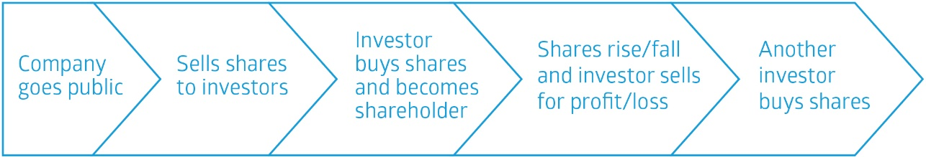

# The Game!

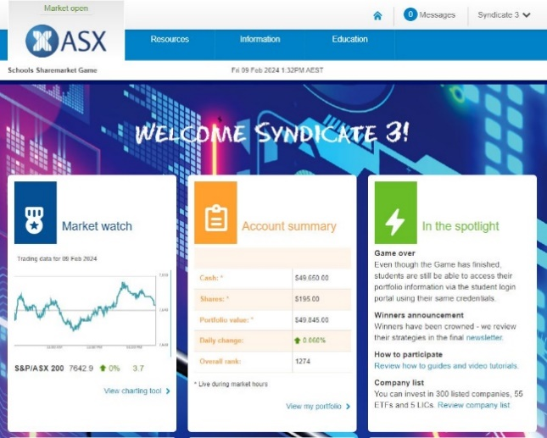**This is your chance to buy and sell shares in the sharemarket** – hypothetically of course. In the Sharemarket Game you get $50,000 to spend on buying or selling shares.

Today you will learn more about how the Game works so that you can jump in and test it out yourself. The Game runs for 10 weeks and there are some pretty good prizes…like cash!

The Game follows the live sharemarket. This means that if BHP shares are worth $46.00 in the live market, this is what you may buy or sell them for in the Game.

If BHP shares move up or down in price, this is also what will happen to the value of your shares.

This is as close as you can get to real life trading.

So let’s take a look at the Game…first of all you need to login.

1. How to login
2. Go to the ‘How to participate’ page <https://game.asx.com.au/game/info/school/how-to-play>
3. Click on ‘Student login link’ at the top right hand side of the page.
4. Enter the Login ID and Password provided by your teacher

Go to the How to participate page (Under the Information tab) and complete activities 2 to 4.

1. Watch the ‘Dashboard tutorial’

(Tutorials will be at the top of the page).

**Answer the following questions:**

* + 1. When you log into the Game what will be the first page you will always land on?

|  |  |
| --- | --- |
|  |  |

* + 1. If you navigate away from the dashboard and want to return, how do you do this?

|  |  |
| --- | --- |
|  |  |

* + 1. Where can you see messages from your teacher or important Game updates?

|  |  |
| --- | --- |
|  |  |

* + 1. If you need extra help, where can you find this?

|  |  |
| --- | --- |
|  |  |

1. Watch ‘Finding your way around the Game’ tutorial

(Tutorials will be at the top of the ‘How to participate’ page).

**Answer the following questions:**

* + 1. Where can you find the company list?

|  |  |
| --- | --- |
|  |  |

* + 1. What is another word for sector?

|  |  |
| --- | --- |
|  |  |

* + 1. List 2 companies in the energy and real estate sectors.

|  |  |
| --- | --- |
|  |  |
|  |  |

* + 1. How can you find out more information about a specific company?

|  |  |
| --- | --- |
|  |  |
|  |  |

* + 1. Why would you use a watchlist?

|  |  |
| --- | --- |
|  |  |
|  |  |

* + 1. How do you create your watchlist in the Game?

|  |  |
| --- | --- |
|  |  |
|  |  |

* + 1. What is a dividend?

|  |  |
| --- | --- |
|  |  |
|  |  |

* + 1. Where can you see the dividends that are coming up?

|  |  |
| --- | --- |
|  |  |

* + 1. Where can you find your ranking?

|  |  |
| --- | --- |
|  |  |

* + 1. List the different types of ranking in the Game.

|  |  |
| --- | --- |
|  |  |
|  |  |
|  |  |
|  |  |

1. Watch ‘How to buy’ tutorial

(Tutorials will be at the top of the ‘How to participate’ page).

**Answer the following questions:**

* + 1. How do you get to the order page?

|  |  |
| --- | --- |
|  |  |

* + 1. Once you have selected a company where can you find the last price of a share?

|  |  |
| --- | --- |
|  |  |

* + 1. What are the two ‘order types’ you can choose from?

|  |  |
| --- | --- |
|  |  |

* + 1. Why is it important to check your order before submitting?

|  |  |
| --- | --- |
|  |  |

* + 1. Once an order is submitted, where can you find it?

|  |  |
| --- | --- |
|  |  |

* + 1. Can you delete or change your order?

|  |  |
| --- | --- |
|  |  |

* + 1. Give 4 reasons why you might you need to change (amend) an order?

|  |  |
| --- | --- |
|  |  |

1. Watch ‘Portfolio’ tutorial

(Tutorials will be at the top of the ‘How to participate’ page).

**Answer the following questions:**

* + 1. Where can you find details of all the shares you have bought or sold as well any corporate actions?

|  |  |
| --- | --- |
|  |  |

* + 1. How will a dividend show up on your transaction page?

|  |  |
| --- | --- |
|  |  |

* + 1. Where can you see your available cash, shares and your total portfolio value?

|  |  |
| --- | --- |
|  |  |

* + 1. Where can you view all the stocks that you presently own in the Game?

|  |  |
| --- | --- |
|  |  |

# Helpful things to know

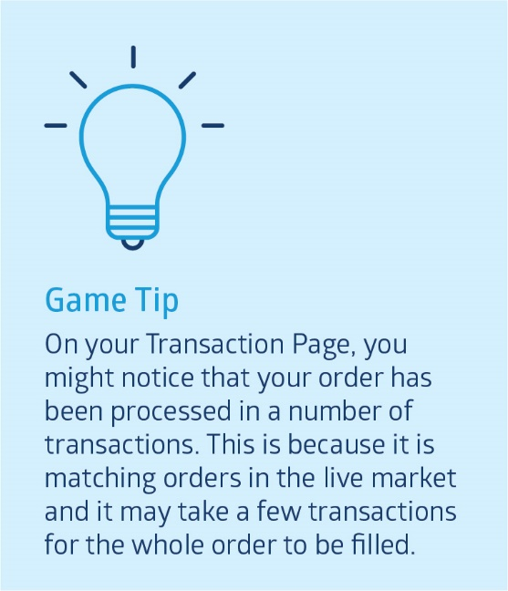Shares are bought and sold using a stockbroker. A stockbroker acts as an agent to buy or sell shares on a person’s behalf. This can be done either online or over the phone. The Game simulates buying and selling online.

## What is brokerage?

There is no fee when an order is placed but when that order is filled and a trade occurs the stockbroker will charge a fee – this is their fee for buying and selling the shares. The brokerage charge can vary depending on the type of broker a person is using.

To find out more about brokerage costs in the Game go to the Game FAQ page.

You need to take brokerage into consideration when buying and selling as this is an additional cost that you will pay every time an order is completed to buy or sell shares. Be careful that you don’t eat into your profits by buying and selling too much because you will end up paying a lot of brokerage.

## What is an order?

An order in the sharemarket is the request that you put in to either buy or sell a certain number of shares in a particular company. Let’s take a look at an order in the Game.

Here you can see we have an order to buy 500 ABC shares using a market order.

You can enter either a market to limit order or a limit order as highlighted in the tutorials How to buy and how to sell. Let’s take a look at the difference.



### Market to limit orders

Knowing which type of order to use is important so you need to understand how they work.

Are you going to go into the market saying I don’t care what I have to pay if buying or I don’t care what I get for these shares if selling? Or do you have a price in mind?

If the market is falling quickly, and this can happen when investors get spooked, then you might find that if you are selling that you get much less than you expected. Or if a stock takes off due to some good news you might pay much more than you expected. Market to limit orders help you to avoid this situation.

When you enter a market to limit order you don’t nominate a price to buy at or to sell at. Instead your order will be filled, as much as it can be, at the current market price then it becomes a limit order.

For example: Suppose you wanted to buy 5,000 shares in XYZ company but there were only 4,000 shares available at the current market price. The system would purchase 4,000 shares for you at the current market price, say $10.00 and then for the remaining 1,000 shares your order would become a limit order for 1,000 shares at $10.00. These shares will only be processed if the price stays at $10.00 or less. If your order is not being processed it may be that the price has moved above $10.00. You can check your pending orders to see if that is what has happened. You can either reactivate the order by clicking amend and making it a market to limit order again or alternatively you can keep it as a limit order but change it to a price you are happy to buy at.

### Limit order

Limit orders let you specify the maximum price you are prepared to pay for shares if buying or the lowest price you are prepared to accept if selling.

Your order will be executed at the best price possible. Suppose you want to buy at a limit of $10.00. You will get them at a lower price if there are shares available at a lower price, but if the price is above $10.00 you order won’t be filled.

If you are prepared to sell at $10.00 but no lower you might end up selling at say $10.50 if prices are higher but not at $9.50 because that is below your limit.

Make sure you are clear what price you are prepared to accept when you put your order in.

If you don’t like the idea of a market to limit order you might consider using a limit order but make sure the price you set it is not too far away from the market otherwise your order might not get filled.

## Can you put all your money into buying one company?

You can do this in real life if you wish; however, there is a belief that this is not the best thing to do as it is very high risk.

In the Game there is a diversification rule that stops you from putting all your money into one company. You can only invest 25% (of your total portfolio value) in any one given company. When you go to place an order to buy shares in a company, the system will tell you how many shares the diversification rule will let you buy, based on the current market price and your portfolio value. You don’t have to buy that number- you can buy less but you can’t buy more. To diversify simply means to invest in different companies and/or different industry sectors that don’t tend to move in the same direction at the same time.

This will help reduce your risk of losing money. Let’s say you invested all of your $50,000 in one company and the shares in this company dropped by 30%. This would mean that your $50,000 investment is now worth only $35,000 – that’s a loss of $15,000. Whereas, if you invested in 4 companies (in different sectors with approximately $12,500 invested in each) and the other 3 companies are doing OK, that 30% loss is now only $3,750 – quite a difference.

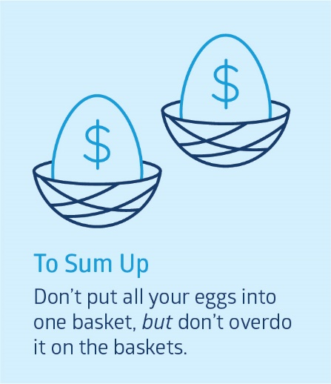Remember, no one knows for certain how different companies or industries are going to perform in the future. So investing in a range of sectors helps reduce risk. Be careful of over diversifying (having just a few shares in a lot of different companies) – because you will end up paying a lot of brokerage and if some companies do really well you want to own enough of them to make some good profits.

## Can I trade any time through the day or night?

You can put your order in at any time; however, as the market is only open between the hours of 10am and 4pm Sydney time, your orders will only be processed over this time.

Tip: If you want to place a trade for the next day, do it after 4.12 pm. The market closes at 4pm however there is a clearing period where trades can still be processed.

# Investigate

1. **Find out which listed companies are associated with the following products or services:   
   (You will need to search other sites for this information.).**

|  |
| --- |
| 1. My Kitchen Rules |
| 1. Bunnings Warehouse |
| 1. Powerade |
| 1. Jetstar |
| 1. Hearing aids / implants |
| 1. Vegemite |

1. **Answer the following**
   * 1. What is brokerage and how much brokerage is charged in the Game?

|  |  |
| --- | --- |
|  |  |
|  |  |

* + 1. What is diversification?

|  |  |
| --- | --- |
|  |  |
|  |  |

* + 1. With a portfolio value of $50,000 what is the maximum amount that you can put into any one company?

|  |  |
| --- | --- |
|  |  |

* + 1. Can you trade at any time?

|  |  |
| --- | --- |
|  |  |

* + 1. What is the difference between a market to limit and a limit order?

|  |  |
| --- | --- |
|  |  |
|  |  |
|  |  |

1. **There are different kinds of stockbrokers, see if you can find out what they are called and why they are different?**

|  |  |
| --- | --- |
|  |  |
|  |  |
|  |  |
|  |  |

1. **Ask your parents or your grandparents if they have any investments or made any investments in the past? Do they think these have been a good investment**

|  |  |
| --- | --- |
|  |  |
|  |  |
|  |  |
|  |  |